AYC Ecology North
December 2012

Bionic Suit Helps Paralyzed Patients Walk Again
By Alyssa Newcomb, ABC News Blogs, gma.yahoo.com

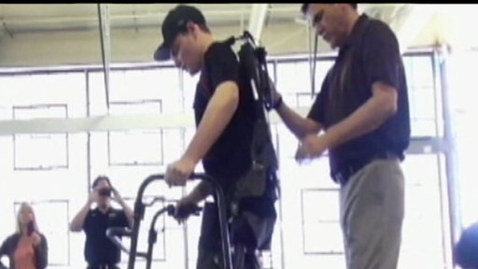

Patients paralyzed by spinal cord injuries are taking their precious first steps at a Southern California hospital with the help of a battery-powered bionic suit that was first designed to help soldiers carry heavy loads.
"Mentally it's a wonderful feeling to be upright and moving," said Aaron Bloom, who was paralyzed two years ago in an accident.
The 27-year-old was told he would never walk again, but with each step in the Ekso Bionic Suit at Huntington Memorial Hospital, he's defying the odds.
"Right now, I don't really need anybody holding me. I can lift my hands up and put a little weight on these crutches and feel pretty comfortable," he said.
The suit, which costs $150,000, is strapped on over a person's clothes. Foot plate sensors help locate the center of gravity so the person wearing the suit can maintain their balance as they take each step. A computer is worn on the back to help drive the hip and knee motors.
The entire suit weighs 45 pounds, but the load is transferred to the ground so the patient does not bear the weight, according to Ekso Bionics, the company behind the breakthrough technology.
It took Bloom weeks of practice to feel comfortable using the suit. He knows it's not a perfect solution, but for now, it is hope.
"I have no doubt in my lifetime that there will be some sort of solution for spinal cord injuries," he said. "I firmly believe that I will be able to walk in the future. It's just a matter of time."

