AYC 2015 CLASS TRIP
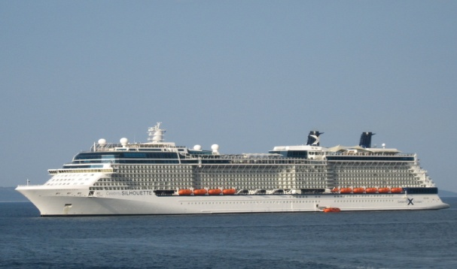

MARCH 13 – 20, 2016
Join Commodore Steve Hyder& Lady Pam
for an unforgettable week aboard
Celebrity Cruises Silhouette
for 7 days in the Caribbean

EARLY BIRD PROMTOIN !!!!!!!
When you deposit by February 27, 2015, you qualify for the Free CLASSIC Drink Package, which includes unlimited beer up to $6.00 per glass, frozen drinks &cocktails up to $8.00 per glass, wine up to $9.00 per glass and soft drinks, espresso, cappuccino and non premium bottled water.This is a value of $343.00 per person !!

7 nights aboard Celebrity Cruises Silhouette in Category 2A Verandah Cabin on deck 7. These are mid ship cabins (other cabin categories available on request).
Onboard Celebrity, experience award winning cuisine and exceptional entertainment.

Celebrity Silhouette Ship Specifications:
Entered Service: 2011 Length: 1,047 feet Cruising Speed: 24 knots
Occupancy: 2,886 Beam: 121 feet Electric Current: 110/220 AC
Tonnage 122,400 Draught: 27 feet
Amenities:
- Friendly, personalized service with a guest to staff ratio of nearly 2.1
- Twice daily maid service
- 24 Hour room service
- Breakfast, lunch and dinner available in a variety of restaurants
- Cabins feature two lower beds convertible to queen. Dual Voltage 110/220AC
- Individual safe
$1,114.86 per person, based on double occupancy Category 2A Verandah

NOTE: Airfare is not included in this price, we will contact you when airfare goes on sale.
Roundtrip transfers are not included: $33.50 per person from Ft Lauderdale and
$60.00 per person from Miami Airport.
Gratuities are not included, they are $84.00 per person
Optional Trip Insurance is $89.00 per person
ITINERARY: ARRIVE DEPART
March 13 Fort Lauderdale 4:30 PM
March 14 At Sea
March 15 San Juan, Puerto Rico 3:30 PM 9:00 PM
March 16 Basseterre, St. Kitts 10:00 AM 6:00 PM
March 17 Philipsburg, St Maarten 8:00 AM 5:00 PM
March 18 At Sea
March 19 At Sea
March 20 Fort Lauderdale 7:00 AM

DEPOSITS:
$250.00 PER PERSON AT TIME OF RESERVATION (Fully refundable up to December 8, 2015
Final Payment due December 8, 2015
YOU MUST BE UNDER DEPOSIT BY FEBRUARY 27, 2015 TO GET THE PROMOTION OF THE CLASSIC DRINK PACKAGE AT NO EXTRA CHARGE!!

SPACE IS LIMITED ANY QUESTIONS OR TO SIGN UP CALL LINDA AT 586-263-4500
RESERVATION FORM

DEPOSIT: $250.00 PER PERSON TO CONFIRM
FINAL: December 8, 2015

NAMES AS APPEARS ON PASSPORTS AND DATE OF BIRTH:

1ST Passenger_________________________________________DOB_______________

2nd Passenger_________________________________________DOB_______________

Mailing Address__________________________________________________________

City____________________________State_______________________ZIP__________

Daytime Phone___________________________Cell_____________________________

Email___________________________________________________________________

T-SHIRT SIZE(S)__________________________________________________________

Attached check in the amount of _____________________Payable to Volare Travel

For Credit Card Payments:

Name of Credit Card________________________________________________________

Expiration Date___________________________Security Code_____________________

Signature__________________________________________________Date____________

Mail to Linda DeAngelis
Volare Travel
42500 Hayes Rd Suite 400
Clinton Twp, MI 48038
586-263-4500 Email: lindavolar@aol.com

CANCELLATION POLICY:
Up until December 8, 2015, deposit is fully refundable.
From December 8, 2015 – January 13, 2016, $250.00 penalty per person
From February 11 – 25, 2016, 50% penalty per person
After February 25, 2016, no refund

