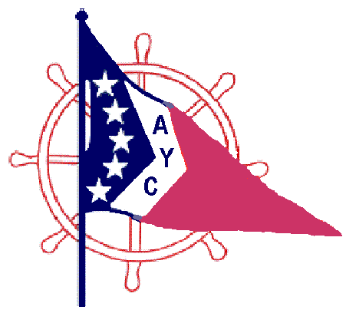
2016 AYC Poker Run Flag Winners

Cooley Canal Yacht Club Detroit Beach Boat Club
David Hensel John Longley & Kimberly
Jeff Sibberson & Jenn Dale Vanderford & Theresa
Scott Sanders & Texanita
Ford Yacht Club Rod Weisnbecker & Michelle
Randy Rankin & Tammie Jim Greenwood & Stacy
Kevin Wilson & Yvonne Dave Arnold & Jeanie
Karyn Selle & Scott
Great Lakes Steel Boat Club Brian Jacobs & Becca
Dan Goodfellow & Kimmie
Tom Kovach & Patty Harbor View Yacht Club
Joe Bacille & Carol Andy Cole & Janice
Jeff Cousino
Lake Front Yacht Club Jeff Gartz & Terri
Jeff Jehl & Amy George Larkin
Bob Stoldt & Michelle
Monroe Boat Club Joe Petersburger & Karen
Kristen Whittico & Timothy
Jim Lachik & Michelle Ottawa River Yacht Club
Gary Horn & Nancy
River View Yacht Club
Mike Valliant & Mary Swan Boat Club
Stan Ziemkiewicz & Cindy Bill Glaeser & Kay
Trent Ziemkiewicz Steve Martin & Diane
Scott Broatz & Lynn Mike McNaughton & Brenda
Scott Rogerson & Janine Diane Wright & Chris
Ron Smith & Lynn
Gary Proctor & Sue Seaway Boat Club
Mark Schuster & Deb Mike Brown & Noella
Dave Walters & Debbie Mark Mendoza
Russ Skitch & Sharon
Sun Parlour Boat Club
Keith Postma Sun Seekers Boating Club
Bill Tuite
Toledo Sailing Club Jerry Hollis & Anna
Deef Labide Jeff Upholzer & Teri

Wyandotte Yacht Club Fleet Captain of the Year
John Dalessandro & Dawn Mike Vaillant River View Yacht Club

Attendance Award: Swan Boat Club (375)
Mileage Award: River View Yacht Club (2250)
Total number of Boats: Detroit Beach Boat Club (89)

