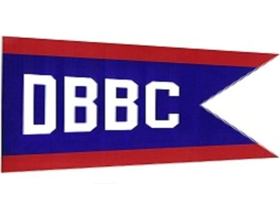
ANNUAL FISH FRY
$15.00 DINNER
FISH, FRIES, SLAW & ROLL
BASKET RAFFLES
50/50 AND MORE
FRIDAY APRIL 10th, 2015
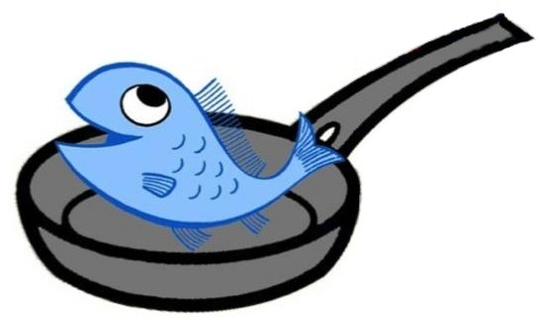
For more information call
VC Scott Sander (734)309-5268
Lady Texanita (520)431-2432

