MRYC Presents
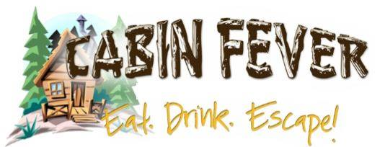
I don’t know about you, but let’s stop thinking about how long it’s been since we were on the boats! And start thinking about what the name of that song is with only 2 notes!!
Our own Jon Bezon is bringing back…….
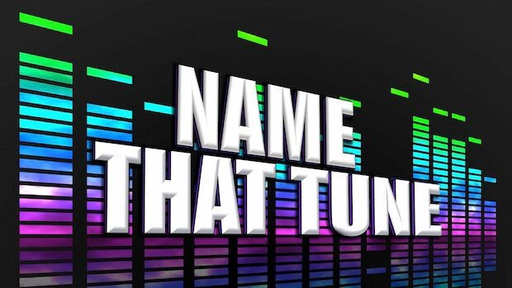
All MRYC Members, family and guests, ……COME ON DOWN!!! Ok wrong game show but you get the picture. (Bob Barker will not be present)
April 1st starting at 7:00pm.
Jon has graciously donated us his time to bring this back along with some musical trivia. You won’t be disappointed!!!
Get a 5 person team together or join one that night starting at 6pm!!
Prizes and raffles!! Bar food available!

