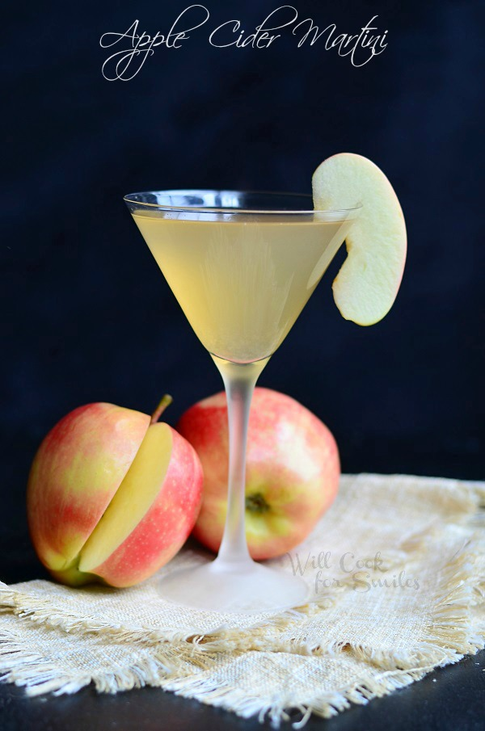

**MRYC Martini Tasting Party**

**With Food Pairings**

**Saturday April 22nd**

**6:00 PM**

**Bet you never had THESE martinis;**

**Cucumber Gin, Happy Elf, Dirty Mary, Jalapeno tequila Bourbon Ball, Purple Rain, Key Lime Pie !!!**

**Just imagine the wonderful foods that our chiefs will combine with these libations!**

**All for only $35.00**

**PLUS. . .A SILENT AUCTION FOR BASKETS CONTAINING ALL THE INGREDIANTS NEEDED FOR ONE OF THESE DRINKS.**

**HURRY . . . RESERVATIONS REQUIRED**

**419-382-3625**