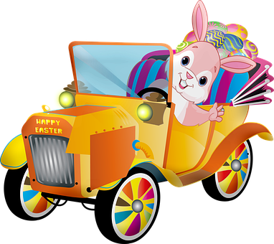

Swan Boat Club

Please join us Sunday, April 5th for Swan Boat’s Club
Children’s Easter Party
The party starts at 2pm
There will be food, an Easter egg hunt and of course the Easter Bunny will be there

The cost is $7 per child
Signup sheet is behind the bar
The signup deadline is Sunday, March 29th
The Easter Bunny is looking forward to seeing you!!

