Mark your calendars and register your boats for the

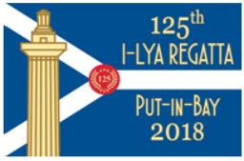
August 3rd through the 5th, South Bass Island

This year marks the 125th I-LYA Regatta and we have a great event planned. Registration on Yacht Scoring https://yachtscoring.com/emenu.cfm?eID=4716 is open for 2018 I-LYA Sail (Bayweek), Steeplechase and Deep-Water Races. Please read the NOR and NOR Addendum. Entry fees increase on July 5th so don’t delay your registrations.
We have the Race Officers for all three courses set. Continuing with improvements made last year, JAM and Cruising Class will have all Island Race courses.
To celebrate the 125th Anniversary, we will have an opening ceremony in DeRivera Park at 4:00 p.m. on Thursday the 2nd followed by viewing of historic trophies and the evening beer tent. We are also requesting that you dress ship while at the dock. (Bring your race flags and hoist them).
Continuing the Social activities, we will have the famous Mount Gay Rum Party on Friday night and for the second year the famous Tito's Vodka Party on Saturday night. Both parties and dinner for three nights are included in the social package.
Social package price is $45.00 per person before July 27 and $60.00 per person after July 27. There will be very few social packages available at the door. To properly plan for the dinners and the parties we need everyone to purchase their social packages before July 27th.
Don't miss out on the fun and be a part of history! Register for the races and purchase your social packages today.
More details can also be found in the I-LYA newsletter as well as information about sponsorship options including Keg Sponsorships!
Finally, smooth sailing to the 2018 Mills Trophy Race competitors. We hope to see you back at the Bay in August.
Bill Pribe—2018 I-LYA Sail Chairman

