SWAN BOAT CLUB

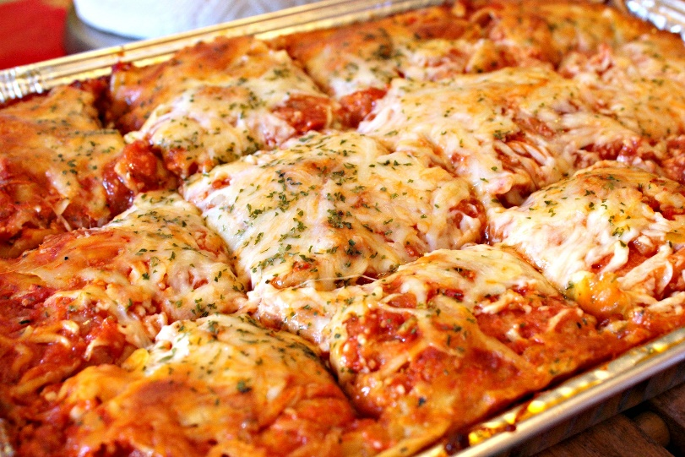

LASAGNA DINNER
Come to Swan on Saturday, August 1st for a Homemade Lasagna Dinner

Includes Lasagna, Caesar Salad and Garlic Bread

We start serving at 5:30pm on Saturday
Dinner cost is $11

