SWAN BOAT CLUB

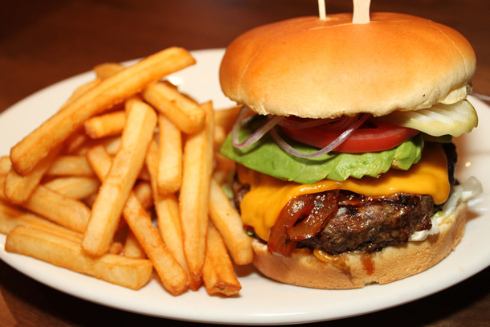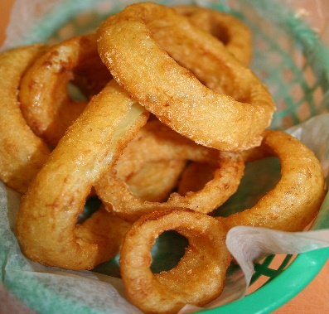

Burger Night
COME OUT FOR OUR FAMOUS
Hamburgers
French Frys, Onion Rings, Coleslaw
Plus all the fixings

5:30PM, in the outside kitchen
FRIDAY AUGUST 14TH
Come Join Us!

