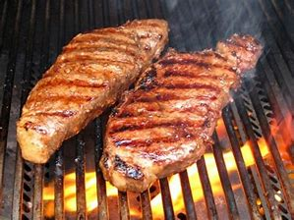

Swan Boat Club Announces-Steak Roast!
Season Opens August 21st 2020
Friday Nights at 5:30

STEAK DINNER WITH ALL THE TRIMMINGS!

Strip/Ribeye - $12 Filet - $13
Chicken - $8

August 21, 28, September 4th, 11, 18, 25
Come Join Us!

