SWAN BOAT CLUB

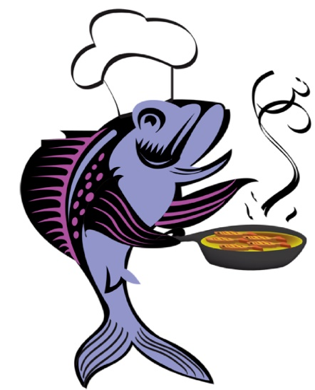 FISH FRY 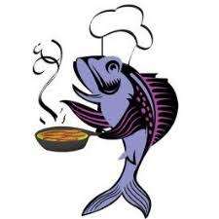
COME OUT FOR OUR FAMOUS
FISH DINNERS
Fish Baked or Fried
Potatoes Baked or Fried
Cole Slaw, Rolls, Dessert
6PM
FEBRUARY 28, MARCH 6 AND GOOD FRIDAY APRIL 10
All You Can Eat, Entertainment at 8pm
$11

