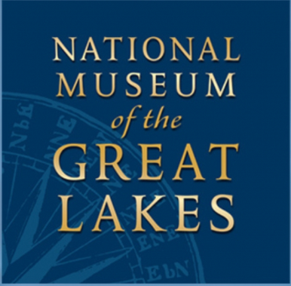
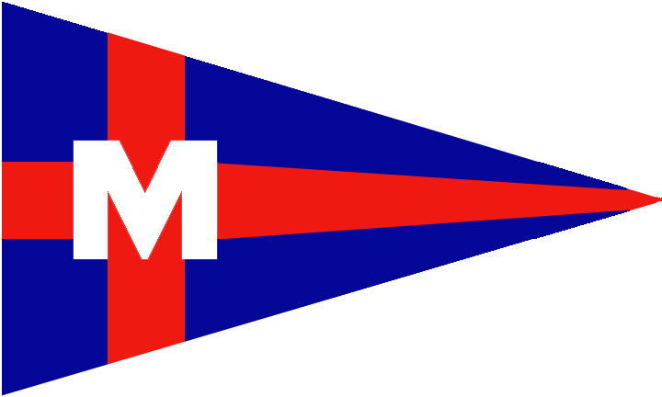
Winter Seminar Series at MBC

Saturday Feb 15, 3:30pm

The National Museum of the Great Lakes presents:
Great Lakes Top Ten:
Our National Story
Stop into MBC for a one-hour presentation on ten of the most important national stories that came from the Great Lakes and learn more about the National Museum of the Great Lakes with our very own Top Ten list!
**No Charge for MBC, I-LYA/AYC Members, Guests and Public**
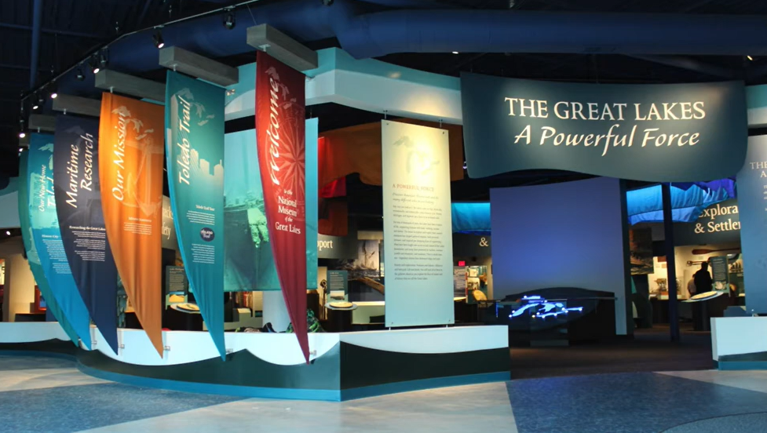

Upcoming Events:
March 15 --
SHIPS, SHIPPING, and
SHIPWRECKS
April 05 –
EDMUND FITZGERALD:
What really happened?

Brought to you by MBC Association
Monroe Boat Club 7932 N. Harbor Drive Monroe, MI 48161

