Winter Seminar Series at MBC

Saturday Jan 18, 3:30pm
The National Museum of the Great Lakes presents:

Titanic and the Great Lakes

Stop into MBC for a one-hour presentation on the loss of the Titanic! The talk includes an overview of the ship, its building, the first trip and sinking. Great Lakes connections to the story will be featured throughout.
Bring your friends for an interesting afternoon.

**No Cost for MBC, I-LYA/AYC Members, Guests and Public**
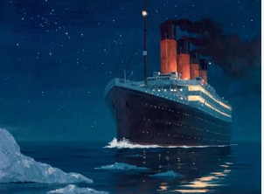

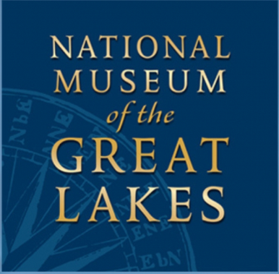
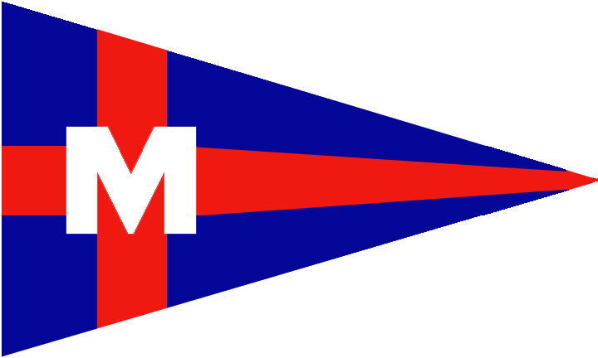

Upcoming Events:
February 15 – GREAT LAKES TOP 10: Ten of the most important national stories from the Great Lakes.
March 15: -- SHIPS, SHIPPING, SHIPWRECKS AND GENEALOGY: History of Great Lakes shipping.
April 05 – EDMUND FITZGERALD: What really happened?

Brought to you by MBC Association
Monroe Boat Club 7932 N. Harbor Drive Monroe, MI 48161

