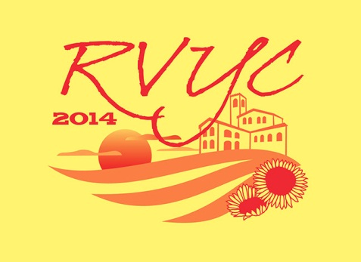

**RVYC Homecoming**

**Friday Steak Dinner**

**Saturday BBQ Chicken Dinner**

**56 DAZE**

**Friday and Saturday**

**7/18 & 7/19**

**5 p.m. – 1 a.m.**

**RVYC Monitors channel 69**