SWAN BOAT CLUB
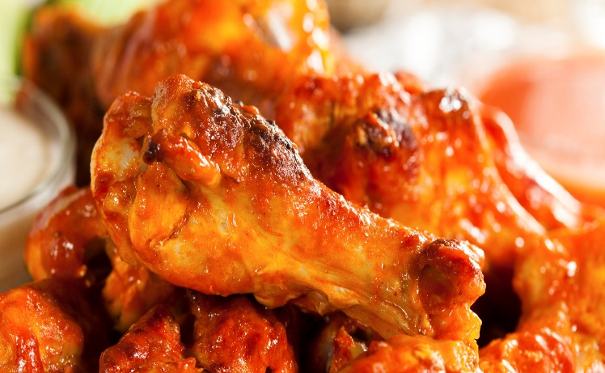

CHICKEN WING DINNER
FRIDAY JULY 24TH
COME OUT FOR OUR FAMOUS
WING DINNER
5 Wings for $4, includes Salad
Basket of Fries or Onion Rings for $3
5:30PM, in the outside kitchen
