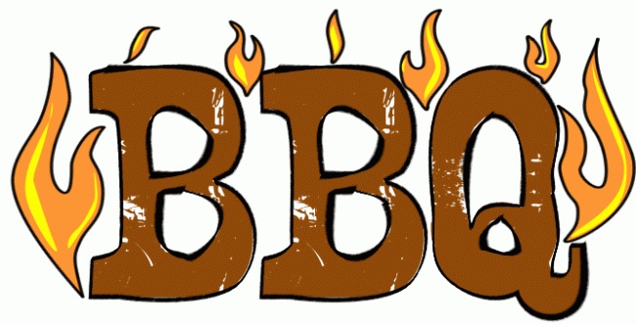
FRIDAY JUNE 20TH
COME SUPPORT DBBC AND HAVE A BBQ CHICKEN DINNER
6:00 PM TILL 8:00 PM
$10.00
BAKED BEANS, POTATO SALAD, ROLLS AND DESSERT
