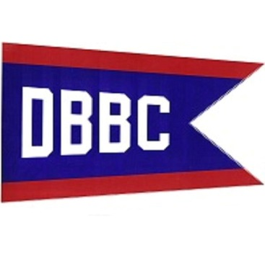
JUNE 12-13, DETROIT BEACH BOAT CLUB LUAU
ADMISSION: $5.00 ADULTS - $3.00 AGES 12/20 – FREE UNDER 12
FRIDAY EVENTS:
DINNER: $10.00 Polynesian
ENTERTAINMENT: Band “Don’t Hold Back”
SATURDAY EVENTS:
BREAKFAST & BLOODY MARY BAR
LEOPA SPRING RUN
Outside kitchen open at Noon
3:00 PM TIKI BAR OPENS
PIG ROAST DINNER $10.00 FROM 6:00 PM – 8:00 PM
ENTERTAINMENT: Band “Armed-N-Dangerous”
SUNDAY EVENTS:
BREAKFAST / BLOODY MARY BAR / ALOHA
