OOTI
WYC Famous Fish Fry

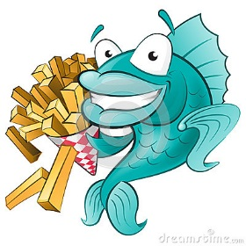
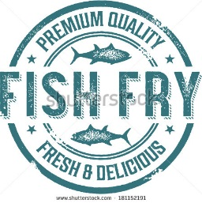

Friday, June 10, 2016
Dinner 6-9 pm (or until sold out)
DJ Scott 7pm –Midnight

Dinner includes
2 pieces of WYC Secret Recipe Beer Battered
Weyand’s Atlantic Cod
Tony Granelli’s famous Cole slaw, fries, roll and dessert.

$13 per person

For Information contact VC Vivian Gebstadt 313-682-4113
Located at Wyandotte Yacht Club 3 James DeSana Drive, Wyandotte, MI

