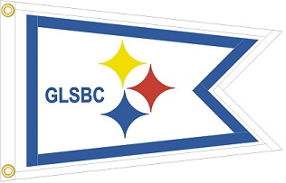2020 Commodore's Fundraising events GLSBC

April 20, 2019 Steel On The River Fishing Tournament
No Cook Thursday's At GLSBC
June 13, 2019
July 11,2019
Sept 12,2019
October 10,2019
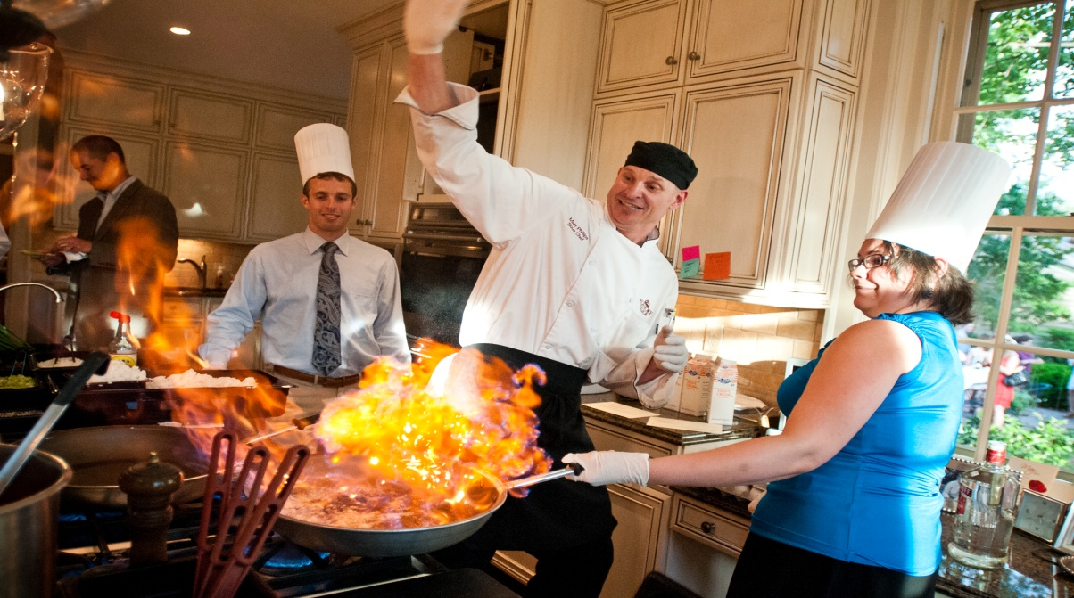
For Info Contact Vice Commodore Randy Pearce
734-752-2909 or email randypearceglsbc@gmail.com

