SWAN BOAT CLUB

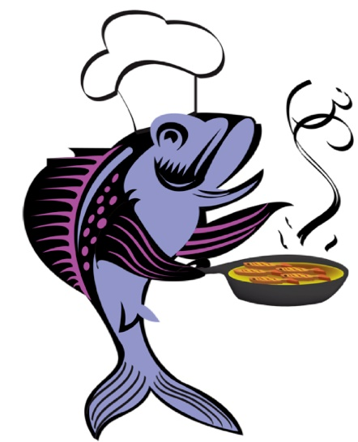 FISH FRY 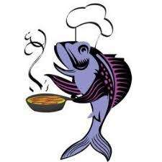

COME OUT FOR OUR FAMOUS
FISH DINNERS
Fish Baked or Fried
Potatoes Baked or Fried
Cole Slaw, Rolls, Dessert
6PM
MARCH 8 AND GOOD FRIDAY APRIL 19
All You Can Eat
$10

