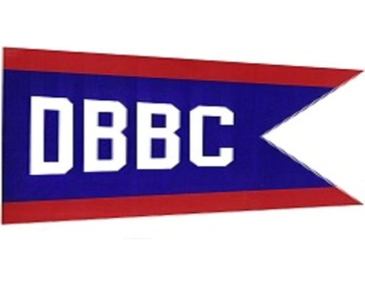
DBBC GOLF HOLE SPONSORSHIP FORM
GOLF : MAY 16th, 2015
LILAC BOLF COURSE
9090 ARMSTRONG ROAD
NEWPORT MI, 48166
$100.00 HOLE SPONSORSHIP
Name:_______________________________________________
Address:_____________________________________________
City, State, Zip:________________________________________
Phone:_______________________________________________
Sign should read

Please return to :
Scott Sander
5941 Lakeview
Newport MI, 48166
Please make checks payable to : Detroit Beach Boat Club
For questions call Scott Sander at 734-309-5268

