MAUMEE RIVER YACHT CLUB BALL INFORMATION
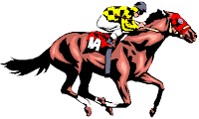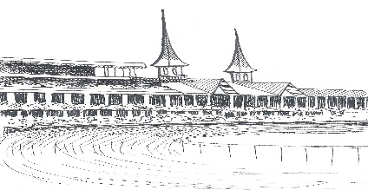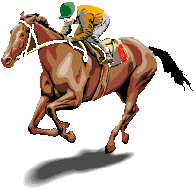
Maumee River Yacht Club’s (MRYC) Ball has a slightly different twist than most of the other AYC/I-LYA Commodore Ball Events.

MRYC always holds their Ball on the day of the Kentucky Derby and that is always the theme. This year is no different. So, what else makes this Ball different?
First: we have all our large screen TV’s tuned into the actual running of the Kentucky Derby during cocktails starting at 5:30 pm in the Taproom.
Second: An assortment of Mint Julips is readily available.

Third: Except for the Commodores, all male guests may wear summer Derby attire. Sport coats, shirts, ties, dress slacks. Hats too.

Fourth: and most importantly, all our female guests may wear their favorite Spring/Summer dress and Southern Belle hat. 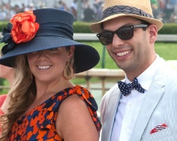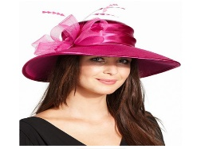

In short, ours is a much more casual Ball with only the Commodores required to wear their Tuxedos.

Invitations have gone out, so please come and celebrate with us and enjoy a little bit of that Old Kentucky Southern Hospitality at MRYC May 6, 2017 5:30 pm

