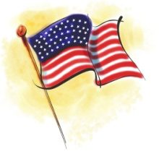 Harbor View Yacht ClubC:\Documents and Settings\jpetersberger\Local Settings\Temporary Internet Files\Content.IE5\LL8INFXZ\MC900174377[1].wmf

Presents

Baby Back Rib Barbeque & Brews

Memorial Day Weekend May 27th 2018

DINNER MENU

½ Slab Baby Back Ribs, Sweet Corn, Potato Salad with Roll $10

OR

Barbeque Chicken Breast, Sweet Corn, Potato Salad & Roll $9

[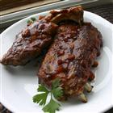](http://allrecipes.com/recipe/scott-hibbs-amazing-whisky-grilled-baby-back-ribs/photo-gallery.aspx) 

Entertainment we be provided by, Cliff Cody

Dinner starts at 5:00pm till all the bones are gone!

Please make you Reservation on the signup sheet so you’re not left with just a brew!!!

Reservations; Tim Weiland 419-290-2901

Walk-ins welcome