Sun Parlour Boat Club
Presents
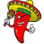
Derby/DeMayo
Come join us at the Clubhouse for 2 Parties in one!
Saturday, May 6th @ 4PM
Enjoy a live-stream of the Kentucky Derby
Cinco de Mayo pre-party
Build-your-own Taco & Nacho Bar with all the fixings Pre-derby horse racing on site
Margarita Sampler
Admission is $15 for this BYOB event
Feel Free to bring a dessert
and a can for Fr. Stan

Please RSVP to ppouget45@gmail.com by May 1st
Prizes for best hats! 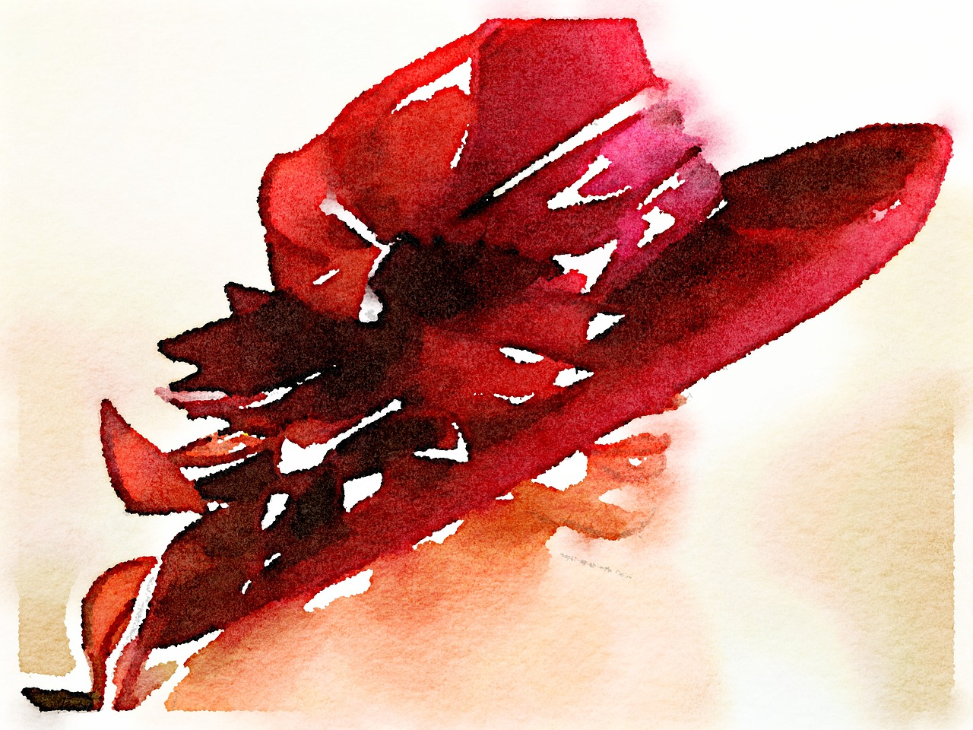
All are welcome!

