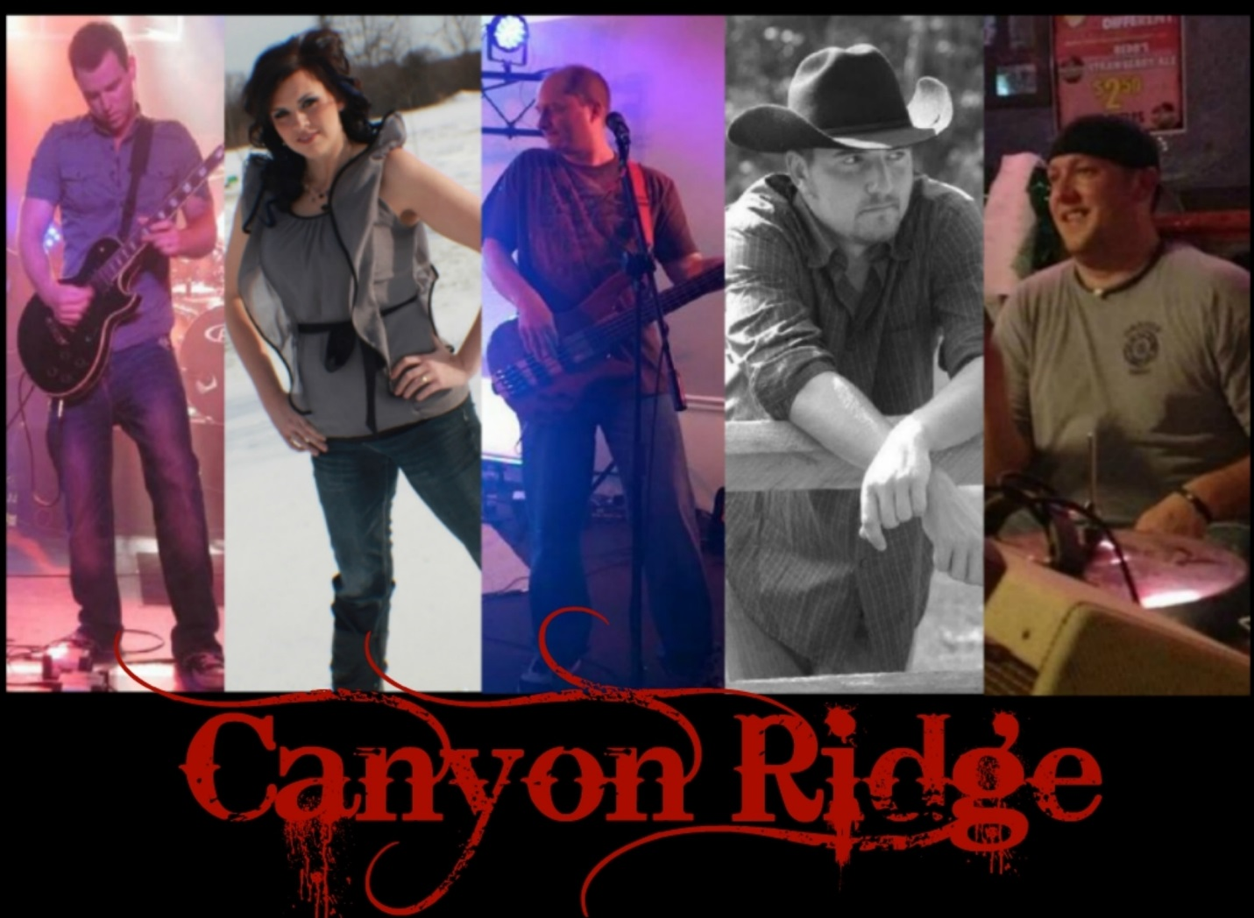
HARBOR VIEW YACHT CLUB
COLOR CRUISE STEAK ROAST
STEAK & CHICKEN DINNERS FROM 6PM –8PM
OCTOBER 3, 2015 5:30PM – 1:00AM
MUSIC AND DANCING TILL 11:30pm
PROVIDED BY CANYON RIDGE
WWW.FACEBOOK.COM/CANYONRIDGECOUNTRY

