SWAN BOAT CLUB IS CELEBRATING
With Triple Header Dining, Dancing and Fun!!!
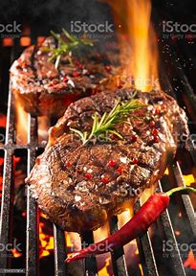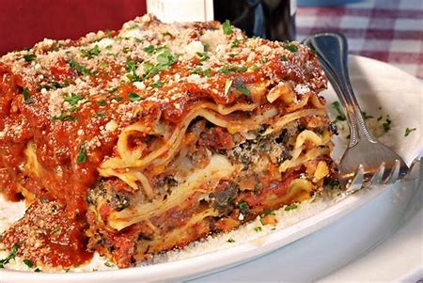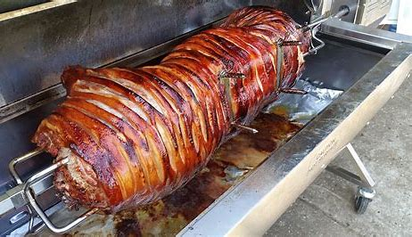
Friday Night: Steak Roast 5:30-7:30pm $15
Entertainment: Pops Garage Band 8pm-midnight
Saturday Night: Lasagne Dinner 5pm-7pm $10
Entertainment: Cruisin’ Jupiter Band 8pm-midnight
****Friday/Sat Night 9-11pm PIZZA ****
Sunday Family Fun Day 1pm-4pm Kids Activities

Sunday Night: Pig Roast Dinner 5pm-7pm $15
Questions? Call Vice Commodore Chris 734-735-4617

