Sylvan Lake brings back marine patrols in wake of accident that killed 2 children
By Tammy Stables Battaglia and Ann Zaniewski, Detroit Free Press Staff Writers

As funeral preparations continued for two children killed when they were hit by a boat while tubing, Sylvan Lake officials on Wednesday announced plans to bring back marine patrols on the lake where the accident occurred.
Sylvan Lake officials said that the city plans to contract with the Oakland County Sheriff’s Office to re-introduce marine patrols on Sylvan and Otter lakes on weekends. The move comes after Sunday’s accident that killed Alexander Mansour, 11, and his sister Gabrielle, 6, of West Bloomfield. Another sister remains hospitalized in critical condition.
In 2010, the sheriff's office — which had marine patrols on the county’s large lakes, including Sylvan and Cass Lake — transitioned to a pay-for-patrol system for lakefront communities because of budget cuts. The communities around Cass and Sylvan lakes have not paid for marine division patrols.
Mayor Mike Zubrzycki said that members of the City Council had talked recently about bringing the marine patrols back. The Mansour family accident reaffirmed the need for the patrols, he said.
“It’s a terrible tragedy. ... I hope this is one step we can take to prevent something like this happening in the future,” he said.
City Manager John Martin said some details surrounding the contract are still being worked out, but the patrols are scheduled to begin Saturday.
The patrols are expected to cost the city $400 to $500 each week, with the money coming from the city’s general fund. The Oakland County Boat Club, a private club on Sylvan Lake, has expressed interest in raising money for the effort, Martin said.
Martin plans to reach out to other communities that border the lakes to see if they’re able to pitch in to help cover the cost. The lakes are also bordered by Pontiac, Keego Harbor and Waterford.
Meanwhile, a funeral mass will begin at noon Friday at Mother of God Chaldean Catholic Church in Southfield for Alexander and Gabrielle, funeral director Jerry Yono of the Southfield Funeral Home said Wednesday.
There will be no visitation, as their parents continue their vigil with the children’s sister, Adriana, 10, Yono said.
Marvin Mansour of West Bloomfield, an uncle of the Mansour children, released a statement Wednesday afternoon saying Adriana was still in critical condition. She is at Beaumont Hospital in Royal Oak.
The Oakland County Sheriff’s Office continues to investigate how the children were hit by a boat Sunday as they were being pulled on a tube by their father, who was operating a personal watercraft on Sylvan Lake.
The boat driver, the children’s father, John Mansour, and others on shore and in other watercraft helped pull the children from the water after they were struck. The boat driver told investigators he saw the personal watercraft, but not the tube.
Marvin Mansour thanked people in metro Detroit and beyond who have offered thoughts, prayers and donations in support of his family. He said a memorial fund in the children’s name will be established soon.
“God bless all of you for all the prayers for Alexander, Adriana and Gabrielle,” he said in the statement sent to reporters.
“Please continue your prayers for our beautiful 10-year-old angel Adriana and hope she makes a full recovery. She remains in critical condition, but we see little signs of improvement and pray they continue.”
Since Sunday’s accident, prayer vigils have been held at Mother of God, the site of the funeral, and other churches in metro Detroit.
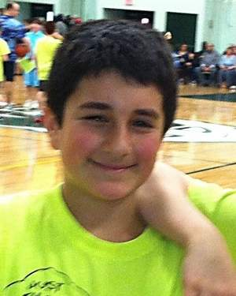
Alexander Mansour, 11, was killed in the accident, as was his sister, Gabrielle, 6.

Sister Adriana, 10, remained in the hospital, in critical condition, as of this writing.

