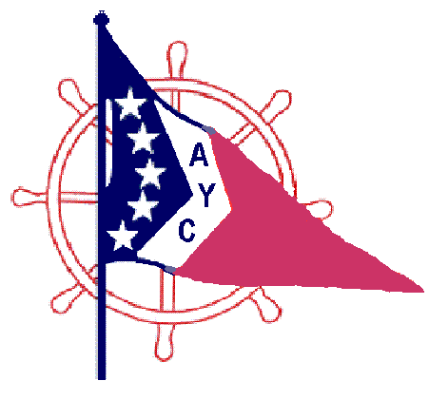 2013 AYC Poker Run Flags

Detroit Beach Boat Club Elba Mar Boat Club
Steve Hyder / Dale Vanderford Bob & Bernace Morrison
Scott Sander

Ford Yacht Club Harbor View Yacht Club
Tom & Kathy MacDonald Lisa and Russ Wells
Dan & Nancy Thomas Larry & Pam Marter
Brian & Dawn Stone Don Durkin
Randy and Doreen Reister Mike & Debbie Grimm
Randy & Tammie Rankin
John & Jeanne Kirkpatrick Monroe Boat Club
Ed & Brenda Rader Brian and Lori Moyer
Rob & Carol Wolas Rick & Wendy Campbell
Scott & Mary Grey Rob Schneider

River View Yacht Club Seaway Boat Club
Gary & Sue Proctor Glenn & Anndrea Johnson
Mark Schuster
SunSeeker's Boating Club
Sun Parlour Boat Club Matt & Cindy Romak
Matt & Maria Morrison Chad & Leeann Gronda
Keith & Denise Posma Jeff & Teri Upholzer
Bill & Linda Deans Matt & Kristin Espinosa
Doug Potier Matt & Jayne Jamison
Gene Easter John & Rita Robbins
Neal & Tatty Bastein George & Melissa Hanrahan
Mark Hendertico & Jeannette Foley
Toledo Sailing Club
Damien & Barb Pfleghaar Wyandotte Yacht Club
Paul Burton Mike & Bonnie Morton
Greg Lowe & Arlene Lafehr

Fleet Captain of the Year: SunSeekers Boating Club F/C Jeff Upholzer

Most Attendance: Most Mileage:
SunSeekers Boating Club SunSeekers Boating Club
Ford Yacht Club Sun Parlour Boat Club
Harbor View Yacht Club Ford Yacht Club

Most Boats:
SunSeerkers Boating Club
Ford Yacht Club
Sun Parlour Boat Club

