Algonac seawall repairs in limbo
Crystal Garcia, 6:24 p.m. EDT September 29, 2014
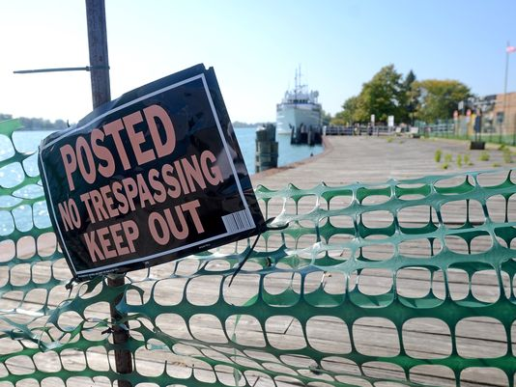
A no trespassing sign is posted, Monday, Sept. 29 along the Algonac boardwalk.(Photo: ANDREW JOWETT/TIMES HERALD, ANDREW JOWETT/TIMES HERALD)
ALGONAC Part of the city's riverfront park will remain off-limits for at least another summer.
About 150 feet of boardwalk north of the Walpole Island ferry dock has been roped off since March 2013 when officials discovered the sea wall there had dropped about a foot and a half.
Since then, city officials have been trying to figure out what happened and how to fix it, City Manager Doug Alexander said.
The city hired an engineering firm to study the sea wall, which took about eight months and $20,000.
Engineers determined the sea walls was dropping into the St. Clair River because the adjacent river bottom had been dredged too deeply, Alexander said.
Part of the evidence included a 1997 Coast Guard permit for dredging depths "that were significantly below the capacity of the seawall," Alexander said.
Despite being undermined, the sea wall remained in place until water levels dropped to near-historic lows, he said.
The Coast Guard leases about 700 feet of sea wall from the city to moor cutters when they're in the area. In addition to the 150 feet of sea wall that has already failed, Alexander said an area starting about 250 feet north of the ferry dock to 330 feet south also is at risk.
City officials met with representatives from the Coast Guard, U.S. Army Corps of Engineers, Sen. Debbie Stabenow's office and Rep. Candice Miller's office earlier this month to discuss the issue.
The city's study results and the Coast Guard dredging permit were handed over, Alexander said. Despite that, the Coast Guard will do its own study.
"The Coast Guard agreed to have its own study done, which unfortunately is not going to be concluded until early next year. Then, hopefully, it will be in the position to make a recommendation on how to fix the wall, other areas in danger and pay for all or a great majority of it," Alexander said.
Lorne Thomas, external affairs officer for the Coast Guard Ninth District, said officials hope to incorporate a lot of the work the city has done, but it needs to do its own review before committing any money to the project.
"This pier is important to the Coast Guard," he said. "We're trying to find a way to help the city with the repair or stabilization of the pier."
He said the Coast Guard needs to not only fix the seawall but also come up with a solution that allows docking its cutters there.
"Our principal interest is for our cutter to tie up there," Thomas said. "The public access is a benefit, but we want to make sure our cutter can tie up safely."
He said the Coast Guard hopes the study will be complete by March 2015. When or if work will be started will depend on available funding.
Options for fixing the problem vary, ranging from replacing the entire sea wall to reinforcing the area with rock. The options also vary in price.
Replacing just the 150 feet of wall that has failed could cost about $500,000, said John T. Monte of Project Control Engineering, the firm the city hired.
"Unfortunately, we're going to have to continue to have that area of the boardwalk fenced off and not available to the public," Alexander said. "We're hoping that a year from now there will be a solution in place, and the repair will be done."
He said there is no imminent danger on the rest of the boardwalk
"People like to walk from one end of the park to the other, and now they have to take a jog around," he said. "It's unfortunate that we're going to have three summers without that available."
Algonac resident Cheryl Edwards also would like to see the boardwalk finished.
She said she visits the waterfront a couple of times a month to go fishing with her sons.
"It's pretty important," she said about the boardwalk. "There are people that walk here up and down every day."
Martha Szymanski has said the riverfront boardwalk has become a big part of the city. She has lived in Algonac for 44 years.
"It's part of a city park. Too bad they can't get it resolved," she said. "I feel bad for the city. They shouldn't have to take on that responsibility."
Contact Crystal Garcia at (810) 989-6276 or cagarcia@gannett.com. Follow her on Twitter @THCrystalGarcia.

