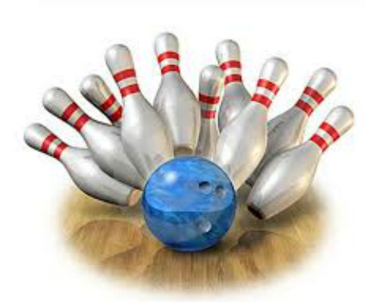
AYC BOWLING
Join Vice-Commodore Joe Petersberger and Lady Karen
for a night of bowling, refreshments and plain FUN!
Friday March 24, 2017 8 P.M.
(Arrive an hour early to register)
Fun for all - 9 pin No-Tap
Monroe Sports Center 15425 S. Monroe St. (734-242-0404)
$20.00PP, includes bowling, balls, shoes, pizza, salad, and more
5 PERSONS PER TEAM-NEED NAMES AND CLUB
1._____________________________________________________
2._____________________________________________________
3._____________________________________________________
4._____________________________________________________
5._____________________________________________________
Contact P/C Rob Wolas for questions 734-676-3827/734-536-0874
14311 Heritage Riverview Mi. 48193
Make checks payable to AYC 2018

