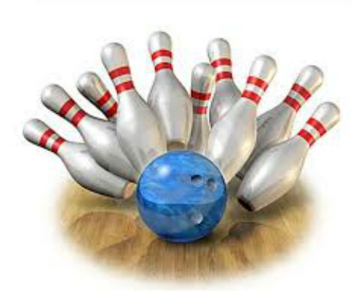
AYC BOWLING
Join Vice Commodore Tom Kovach and Lady Patty
for a night of bowling, refreshments and plain FUN!
Friday March 23, 2018 8 P.M.
(Arrive an hour early to register)
Fun for all - 9 pin No-Tap
Monroe Sports Center 15425 S. Monroe St. (734-242-0404)
$20.00PP, includes bowling, balls, shoes, pizza, salad, and more
5 PERSONS PER TEAM-NEED NAMES AND CLUB PLEASE
1._____________________________________________________
2._____________________________________________________
3._____________________________________________________
4._____________________________________________________
5._____________________________________________________
Contact Rob Wolas for questions 734-676-3827/734-536-0874
3897 14th Street Wyandotte, MI 48192
Make checks payable to AYC 2020

