JOIN COMMODORE
JOSEPH PETERSBERGER & LADY KAREN
FOR A CRUISE ABOARD THE
NORWEGIAN BLISS
MARCH 09-16, 2019
FOR A 7 NIGHT EASTERN
CARIBBEAN CRUISE
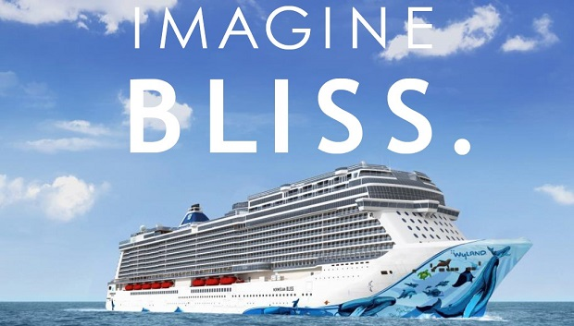

BC-BALCONY $1,380.05 PER PERSON (Based on Double Occupancy) cruise only
Midship Cabins Located mainly on Deck 9 & 10

PICK TWO OFFER
Ultimate Beverage Package *1st and 2nd guest only (value $750.00 per person)
Prepaid Gratuities *1st and 2nd guest only (value $97.93 per person)
Free Shore Excursions *Max of 4 ports -$50.00 per Port (value $200.00 per cabin)
Free Special Dining Package *1st and 2nd guest only (value of $99.12 per person)

ITINERARY ARRIVE DEPART
MARCH 09 MIAMI, FLORIDA 4:00PM
MARCH 10 AT SEA
MARCH 11 AT SEA
MARCH 12 ST. THOMAS, U.S. VIRGIN ISLANDS 8:00AM 6:00PM
MARCH 13 TORTOLA, BRITISH VIRGIN ISLANDS 7:00AM 3:00PM
MARCH 14 AT SEA
MARCH 15 NASSAU, BAHAMAS 12:00PM 7:00PM
MARCH 16 MIAMI , FLORIDA 8:00AM

Deposit: $250.00 per person (based on double occupancy)
(fully refundable until final payment)
Final Payment Due: October 9, 2018

Travel Protection: Standard - $115.00 per person
Platinum - $175.00 per person
Note: Airfare is not included in this price, we will contact you when airfare goes on sale.
Roundtrip transfers: Miami Airport $32.00 per person
Ft. Lauderdale Airport $50.00 per person

Call Tracey at Volare Travel to Book your 2019 AYC Norwegian Cruise
586-263-4500 or email Tracey@volaretravel.com

