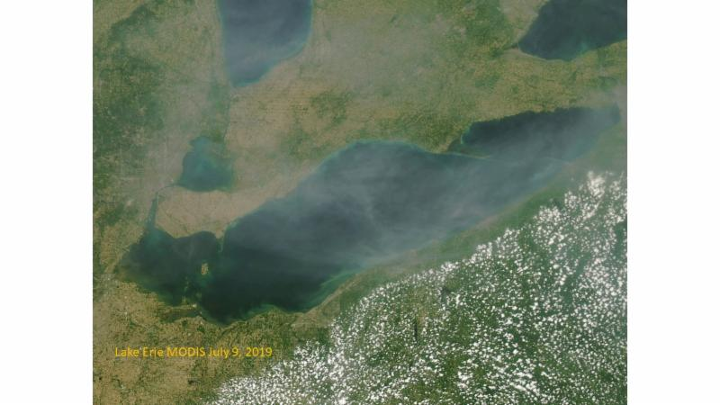
2019 Lake Erie algae forecast July 11 from 11-1 Register here Hear the Lake Erie harmful algae forecast from the experts that the news will be reporting on.

Lake Erie Waterkeeper Meeting Thursday 7 pm Toledo Yacht Club
Presentation Lake Erie Metroparks Scott Carpenter and Tim Schuetter from Toledo Lucas County Metroparks will speak on the parks and algae followed by Lake Erie Round Table discussion. Agenda

Bill Stowe , Des Moines Iowa was a true water hero on the algae issue. Here is his presentation from 2015 Part One , Part Two . spoke at a Lake Erie Waterkeeper Conference in 2015 .

Lake Erie Water levels June 2019 break records - high levels predicted through summer Scientists are telling us that the Great Lakes are going to experience more frequent highs and lows because of climate change. The good news is that predictions do not include increases in the highs and decreases in the lows.

Lake Erie Algae Forecast 2019 - NOAA says much worse than last year.. Mississippi bans swimming at all beaches because of algae/dead zone

Summer meetings on status of Great Lakes. Canada concerned about plastics and toxins in Lake Erie

Join us for a Lake Erie Conference Call discussing Lake Erie Sunday evening, July 28 at 8 pm

Have an event this summer where you would like to have Lake Erie information or volunteer to table at events, please contact sandylakeerie@aol.com

