**2020 AYC Class**

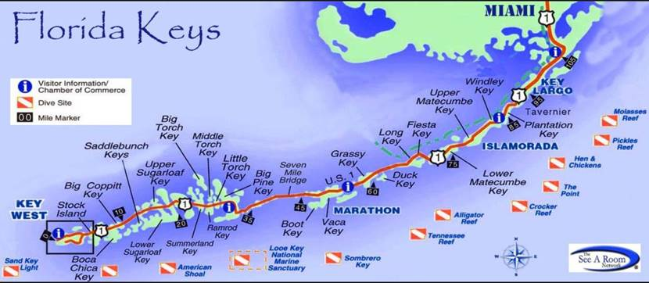

**Travel the FLORIDA KEYS with Commodore Stan Ziemkiewicz & Lady Cindy**

**March 12 – 20, 2021**

**Hotel prices only – modifications available upon request – If you need airfare, car rental or additional hotel accommodations. Credit card needed to guarantee or charge first night at time of booking.**

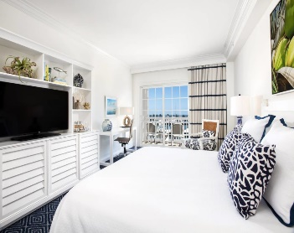 ***Key West*** – **March 12-16, 2021 - 4 nights**

**Ocean Edge Resort & Marina**

Partial Ocean View Balcony - King $1,674.92 *total for 4 nights\**

Partial Ocean View Balcony – 2 Queen $1,782.92 *total for 4 nights\**

Ocean View Balcony - King $1,962.92 *total for 4 nights\**

Ocean View Balcony – 2 Queen $2,070.92 *total for 4 nights*

* *Resort Fee included: $37.00 plus tax. Per night per room.*

*Not included: On-site parking is available for $20 per night plus tax per vehicle and parking space required*

Free cancellation is included if 72-hour notice prior to arrival is provided to the resort.

Confirmed reservations require first night plus tax as a deposit.

Special Promotion – includes

• Tropically inspired elegant accommodations

• 2 welcome cocktails • Complimentary 2-hour kayak, paddleboard, or bicycle rental

• Shuttle service to Key West Historic Seaport (Downtown) • Personalized in-room entertainment via 49-inch Smart TV• Access to Digital Concierge services• Access to complimentary resort activities, 24-hour gym, and lawn games• Access to 6 heated pristine pools with poolside refreshment service• Access to a deep-water full marina with a variety of water activities

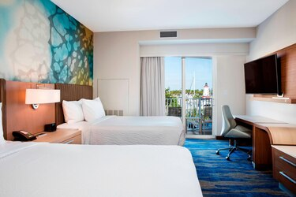 ***Marathon*** - **March 16-18, 2021 - 2 nights**

*(Partial Oceanview w/balcony room above)*

**Courtyard Marathon Florida Keys (Marriott)**

King Guestroom with breakfast $897.75 *total for 2 nights\**

2 Queen Guestroom with breakfast $875.25 *total for 2 nights\**

Partial Bay View King w/balcony room w/breakfast $965.25 *total for 2 nights\**

Partial Bay View 2 Queen w/balcony room w/breakfast $942.75 *total for 2 nights\**

*\*Destination Amenity Fee included: $20.00 plus tax per room per night.*

Free Cancellation (1 day before arrival)

Confirmed reservations – Credit Card Guarantee required.

Amenity Fee includes:

• 20 daily food/beverage credit

• signature cocktail for 2, bikes and 2 beach chairs.

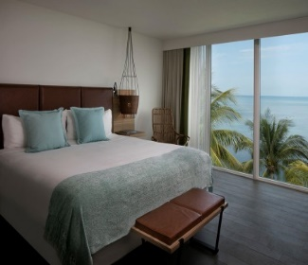 ***Islamorada*** - **March 18-20, 2021 - 2 nights**

*(All rooms have a balcony)*

**Amara Cay Resort**

Standard King Room w/Sun, Sand and Drink in Hand $999.13 *total for 2 nights\**

Standard 2 Queen Room w/sun, sand and Drink in Hand $1,043.68 *total for 2 nights\**

Matacumbe Courtyard view -King Lanai w/Sun, Sand & Drink $1,223.91 *total for 2 nights\**

Matacumbe Courtyard view -2 Queen Lanai w/Sun, Sand & Drink $1,268.45 *total for 2 nights\**

Alligator Reef – Partial Oceanview King w/Sun, Sand & Drink $1,201.63 *total for 2 nights\**

Alligator Reef – Partial Oceanview 2 Queen w/Sun, Sand & Drink $1,313.01 *total for 2 nights\**

*\*Resort Fee included: $35.00 + Tax per room per night.*

Free cancellation is included if 72-hour notice prior to arrival is provided to the resort.

Confirmed reservations require first night plus tax as a deposit.

Sun, Sand, and Drink in Hand Promotion:

Free cancellation up to 3 days before arrival

Enjoy the good life with our Sun, Sand and Drink in your hand offer.

Take advantage of up to 30% off plus two welcome drinks!

*To Secure your reservation call or email Tracey Roe at Volare Travel*

[***Tracey@Volaretravel.com***](mailto:Tracey@Volaretravel.com)***. Work – (586)263-4500***

***Cell – (586) 419-7959 Monday – Friday 10:00am – 6:00pm***

**Travel the FLORIDA KEYS with Commodore Stan Ziemkiewicz & Lady Cindy**

**March 12 – 20, 2021**

***\*\*All pricing subject to change until reserved***

**Ocean Edge Resort & Marina – March 12-16,2021 4 nights**

___Partial Ocean View Balcony - King $1,674.92 *total for 4 nights\**

___Partial Ocean View Balcony – 2 Queen $1,782.92 *total for 4 nights\**

___Ocean View Balcony - King $1,962.92 *total for 4 nights\**

___Ocean View Balcony – 2 Queen $2,070.92 *total for 4 nights*

**Courtyard Marathon Florida Keys (Marriott) – March 16-18, 2021 2 nights**

___King Guestroom with breakfast $897.75 *total for 2 nights\**

___2 Queen Guestroom with breakfast $875.25 *total for 2 nights\**

___Partial Bay View King w/balcony room w/breakfast $965.25 *total for 2 nights\**

___Partial Bay View 2 Queen w/balcony room w/breakfast $942.75 *total for 2 nights\**

**Amara Cay Resort – March 18-20,2021 2 nights**

___Standard King Room w/Sun, Sand and Drink in Hand $999.13 *total for 2 nights\**

___Standard 2 Queen Room w/sun, sand and Drink in Hand $1,043.68 *total for 2 nights\**

___Matacumbe Courtyard view -King Lanai w/Sun, Sand & Drink $1,223.91 *total for 2 nights\**

___Matacumbe Courtyard view -2 Queen Lanai w/Sun, Sand & Drink $1,268.45 *total for 2 nights\**

___Alligator Reef – Partial Oceanview King w/Sun, Sand & Drink $1,201.63 *total for 2 nights\**

___Alligator Reef – Partial Oceanview 2 Queen w/Sun, Sand & Drink $1,313.01 *total for 2 nights\**

**Last Name ____________________________________First __________________________Middle ______________________**

**Date of Birth______________________________**

**Mailing Address___________________________________________________________________________________________**

**City __________________________________________________State __________________________Zip __________________**

**Email ________________________________Cell Phone #____________________________Home #____________________**

**2nd Passenger Legal Name as it appears on Passport**

**Last Name ____________________________________First ___________________________Middle _____________________**

**Date of Birth_________________________________________**

**Mailing Address___________________________________________________________________________________________**

**City ___________________________________________________State __________________________Zip _________________**

**Email __________________________________Cell Phone # ___________________________Home #___________________**

**Boat Club you belong to:___________________________________________________________________________________**

**Credit Card Payment: $_____________________ or Mail Check Payment: $_______________________**

**Name on Credit Card ______________________________________________________________________________________**

**Billing address if different from above ______________________________________________________________________**

**City _____________________________________________________ State ________________________Zip ________________**

**Card Number: last 4___________________________ Expiration_________________ Security Code__________________**

**Signature ______________________________________________________________________ Date _____________________**