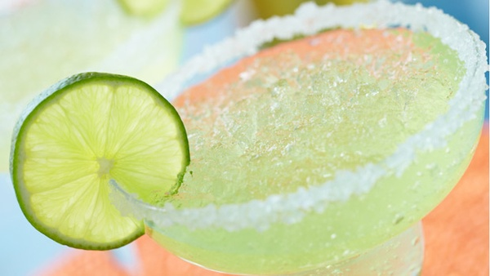
The 7th Annual
MARGARITA PARTY
and TASTE OFF!
April 14th at 6pm
CONTESTANTS
NEEDED!!!
WE NEED 6 ENTRIES TO FILL THE BALLOT
SEE BARTENDER FOR RULES!!!!

