at the
BACK TO THE BAY PARTY
TOLEDO YACHT CLUB
3900 N. SUMMIT ST. TOLEDO, OHIO 43611 419-726-3485
SATURDAY, 4.14.18
DOORS OPEN AT 6PM
Featuring on the upper deck
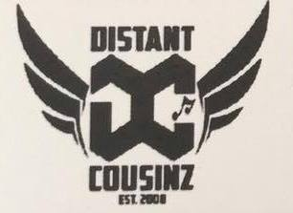
voted “best area band” by city paper

Paul Spoerl, Entertainment Network Disc Jockey,
will be spinning the tunes for you on the Lower Deck

Cash Bar ~ 21 AND OVER ~ $10.00 w/I.D.
OPEN TO THE PUBLIC

