MAUMEE/SANDUSKY BASINS PROJECT GETS EPA FUNDING
CTIC, in partnership with Ecosystem Services Marketplace Consortium (ESMC), Heidelberg University in Ohio, and others, received a $472,000 Great Lakes Restoration Initiative (GLRI) grant from the U.S. Environmental Protection Agency.
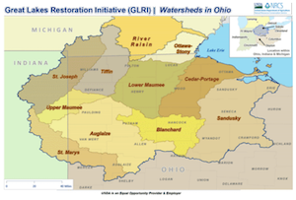 | The grant will fund a three-year project in the Maumee and Sandusky river basins that aims to reduce phosphorous loads by 40 percent using subsurface application, cover crops and buffer strips and the principles of The Fertilizer Institute's 4R Nutrient Stewardship. Technical support will be provided by TFI and the Soil Health Partnership (SHP).  As farmers implement conservation systems, we will use Operational Tillage Information System (OpTIS) data and Heidelberg University's Nutrient Tracking Tool to set baselines and follow the effects of the management practices over time. ESMC will enable water quality trading for P credits, coordinate a pay-for-performance model, and link farmers with buyers seeking sustainably produced commodities.
"Through this partnership with farmers, researchers, market makers, and nonprofits, we will create the ability to quantify and reward farmers for their reductions in phosphorus loss," says CTIC executive director Mike Komp.

Excerpt from Conservation Technology Information Center

