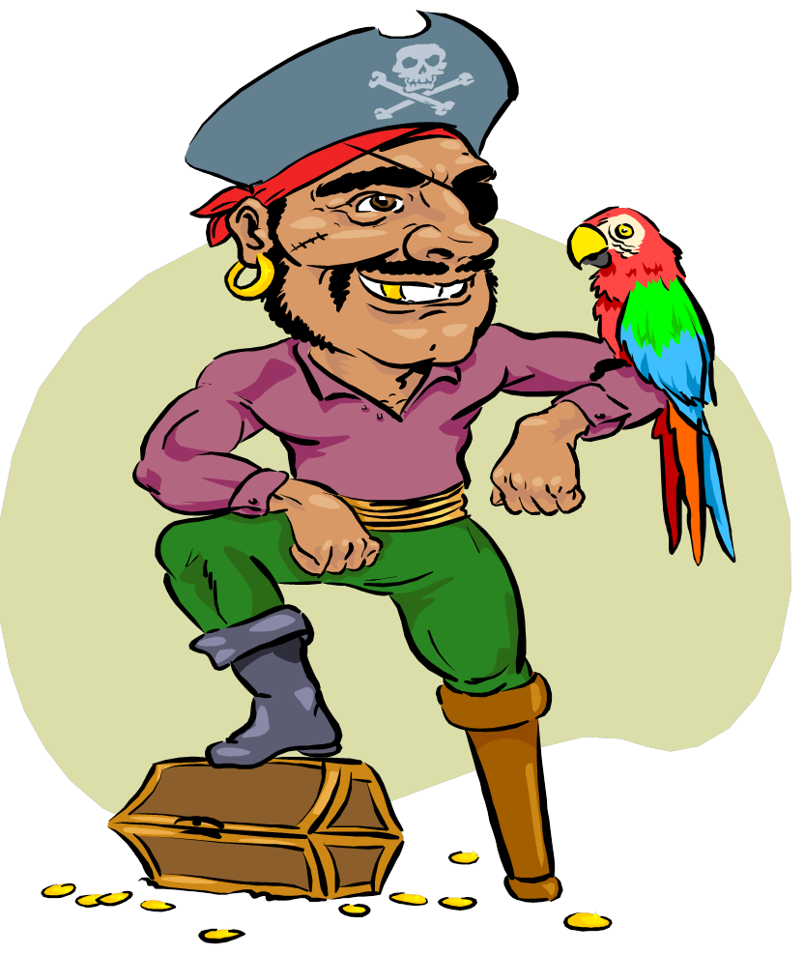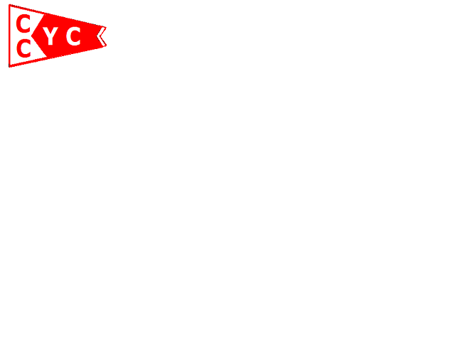

Located at the Bono Curve

Come one come all, enjoy the summer fun

At CCYC

COOLEY CANAL

YACHT CLUB

12235 Bono Road, Curtice, Ohio

7th Annual

Skid Row Chicken Dinner

$8.00 includes all of the fixings

Dinner served at 4pm

SATURDAY, August 17th

The annual Golf Cart Rodeo/Poker Run Starts at 2pm

Music & Dancing starting at 6pm

Cash Bar

Only 200 Tickets Sold

FRIDAY, JUNE 15th - 5:00 pm - 12:30 am

Chicken Dinners - 1:00pm - 7:00 pm

Car Show by OUTLAW CRUISERS

12:00 pm - 4:00 pm

Car Show Registration 9:00am -12:00pm

Music by “BIG TICKET” 8:00 pm - 12:00 am

SUNDAY, JUNE 17th

Raffle at Noon for:

Cash, iPad 3, Cooler of Booze

Located: St Rt 2 at Bono Curve

OPEN TO PUBLIC FRIDAY & SATURDAY

Weekend Wristbands: $2.00 Friday 5:00pm - Saturday 6:00pm

$5.00 Saturday after 6:00pm