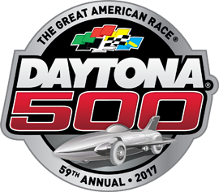
PARTY!
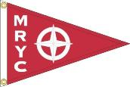
At Maumee River Yacht Club
February 26th at 10am
Bloody Mary Bar
Board Games
Tailgate menu available
Come down and root on your favorite driver!!!

