MRYC’s
8 Weeks 2 Whiskey Light Party!!
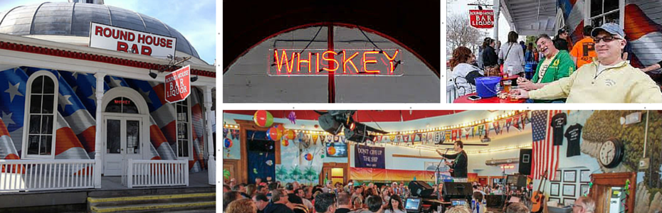
PRESENTING
FEBRUARY 25th at 5:30 to 11pm
Pre-Sale Tickets only!! $35/ person NO REFUNDS
Includes: Drunken Patio Chicken Dinner and show.
Must have ticket at door! MUST BE 21 Years Old!
Tickets go on sale Jan. 18th at MRYC

