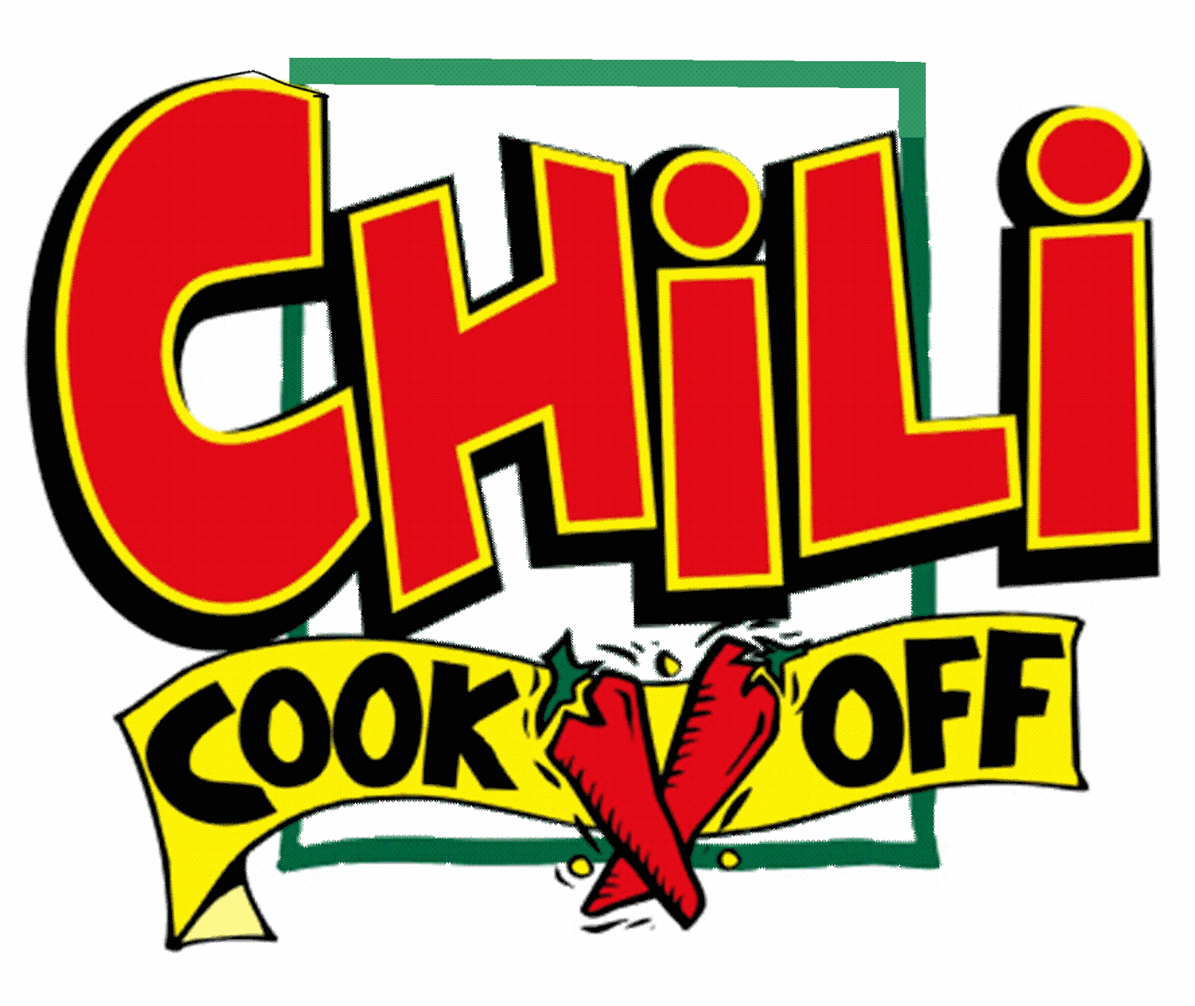

SWAN BOAT CLUB

SUPERBOWL SUNDAY FEBRUARY 3, 2019

Euchre Tournament 2pm

SUPERBOWL PARTY AND CHILI COOK OFF 4:30

Hot or Mild, Tame or Wild, bring a pot of your favorite Chili recipe
for our Annual Chili Cook Off

Tasters donate $5 to taste everyone’s Chili and cast their vote

Our Club will provide shredded cheese, onions, jalapenos, crackers, chips and snacks for the cook off

