DBBC
BOWLING
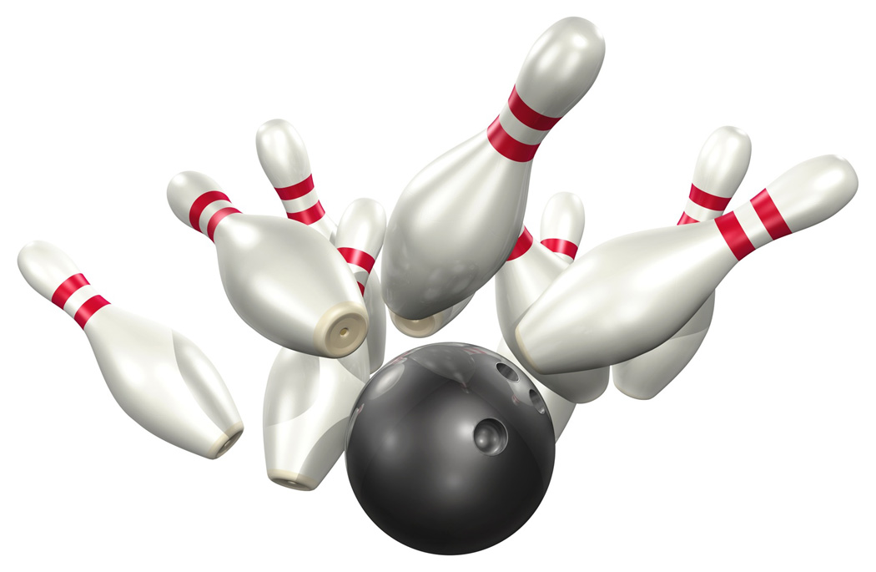
COME ENJOY SOME BOWLING, RAFFLES AND, FRIENDSHIP WITH DBBC ON JANUARY 10TH, 11:00 AM.
$20 PER PERSON INCLUDES BOWLING, SHOES, PIZZA AND, POP
THERE WILL ALSO BE 50/50 AND BASKET RAFFLES
COME SUPPORT OUR ANNUAL HOSPITALITY ROOM FOR DETROIT BEACH BOAT CLUB
Thank you, Vice Commodore Scott Sander

