Submitted by Paul Peterson, Michigan DNR
Picture is of Leland Harbor:
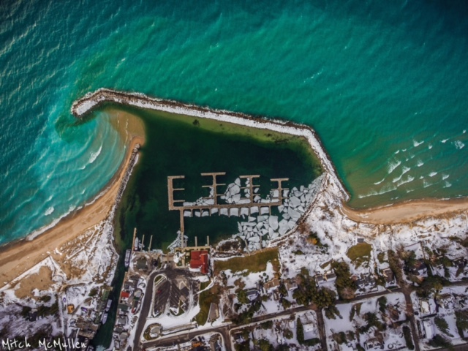

Leland Township Marina continually struggles year after year with low water levels at the Federal navigational channel harbor entrance. In 2013 the harbor was dredged during the Emergency Dredge Program. The last dredge at the harbor was the next year in 2014. In March 2016, the Waterways program offered Leland Township a grant for $100,000 State funding/$100,000 Local Match that was to be completed by the end of 2016. Unfortunately the community ran into permit issues and was not able to use that grant funding. The DEQ permit issue was relative to spoils placement. DNR fisheries found the nearshore areas, south of the harbor, are being used by several species of fish…including Whitefish, Coho, minnows, and a large abundance of Alewife and Smelt. The grant remains on hold at this time in case Leland decides to apply.

As evidenced by the attached December 2016 air photo taken of the harbor entrance, and today’s news article in the Traverse City paper…the harbor is again experiencing an extreme situation due to recent storms that pushed sediment into the channel resulting in a shallow passage , resulting in the need to dredge at the entrance channel in order to access the marina and to accommodate the Manitou Island Transit.

For your review is a January 4, 2017 newspaper article we received today that indicates the community wishes to purchase a $500,000 dredger and then the Township would be able to do their own dredging as it is a recurring issue. I had discussions last summer with the Leland Township Harbormaster and the Harbor Commission Chair regarding the possibility of a Waterways grant to assist in the purchase of dredge equipment. Note we have not received any recent requests.

Ed Note: The newspaper article is in the link above this, but the picture and the information contained here are what is important. It depicts an ongoing battle with nature and the local people standing against the government to take care of themselves.

