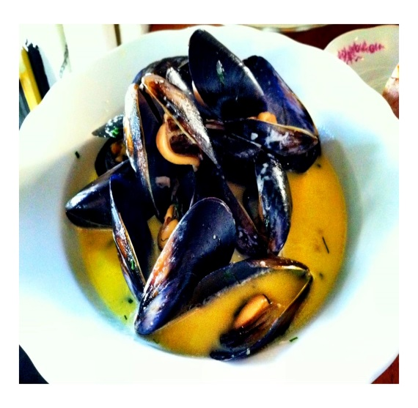
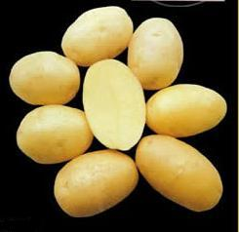
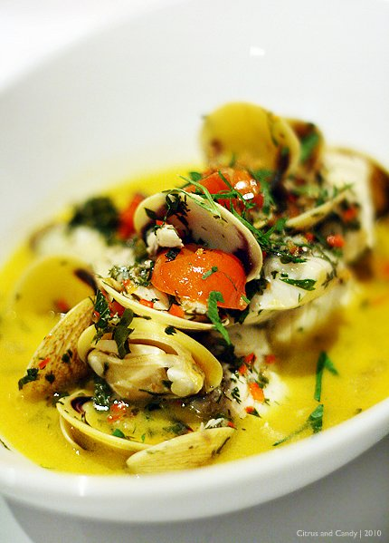
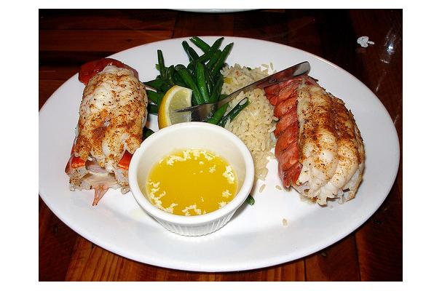
RVYC Clam Bake

Fundraiser for Commodore’s Ball
When: Wednesday 6/14
Time: 5:30 pm until 7:30 pm
Menu: 2 Lobster Tails
Clams
Mussel
Red Skin Potatoes
Salad
$25.00 per Person
For Reservations Call or Text
Stan Z at 419-708-7886

