Lake Erie Waterkeepers Report
March 2020
Delegate Phil LaCourse

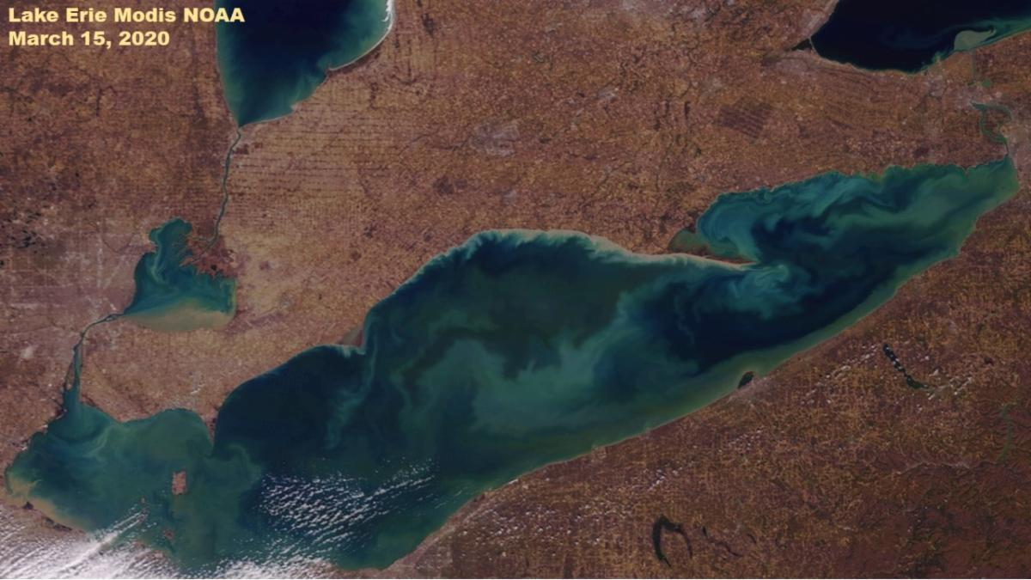

All
I am blessed to look out the window and see Lake Erie's waters every day in these 'Stay Home' times . I see the ducks flying in and the spring bird migration beginning. An awesome time to observe the shoreline.
While enjoying spring migration, water levels are near or at record highs. We went to Port Clinton over the weekend for take out at Jolly Rogers(perch was very good) and ate in the parking lot next to the Port Clinton lighthouse where we saw the benches under water and debris is the parking lot from higher waters during high winds. Then this week we got a sandwich and went to Bolles Harbor and families fishing from the shore and boats coming in. Just as in Port Clinton, the high waters were lapping the pavement edges and it was apparent that the recent high waters put debris on the parking lot there too.
So while we try to stay safe from the virus, we also are worried about high water levels that will flood and erode the shoreline which is already stressed from a winter with little to no ice. And Lake Erie is not alone, all of the Great Lakes are facing similar spring threats.
Sadly, in the best walleye season ever, charters cannot go out because of the virus. Spring has been the dependable unlike the simmer algae. Hoping charters get economic help so they can continue to operate.
SPRING WISH - VIRUS UNDER CONTROL - LITTLE RAIN - LOW WINDS - FARMERS GET TO PLANT.
Also wondering about getting our boats in the water.
Take Care - Be Safe
Sandy
Below are some Lake Erie updates, webinars and information
- Michigan has a virtual town hall on March 26 on water levels.
Register here.
- NOAA has a water level webinar April 13 Register here
- Army Corps current water level information here
- For the kids, Michigan Sea Grant has a daily video from 10:30 to 11 am with
fun information and family challenges. Link
If you want more water education fun links email
- The waterkeeper meeting is April 9 and will be by conference call at 7 pm.
The dial in number is 605-475-3220 Code 767451# Agenda sent week of call
- Ohio has permits out for comment for two hog facilities that will add 4800
hogs/manure in the Maumee watershed. The April meetings have been
postponed. More info to come
- The Lake Erie Conference including the Western Lake Erie Report Card release has been postponed until August 14 and will be held at the Toledo Yacht Club. Information and registration here

