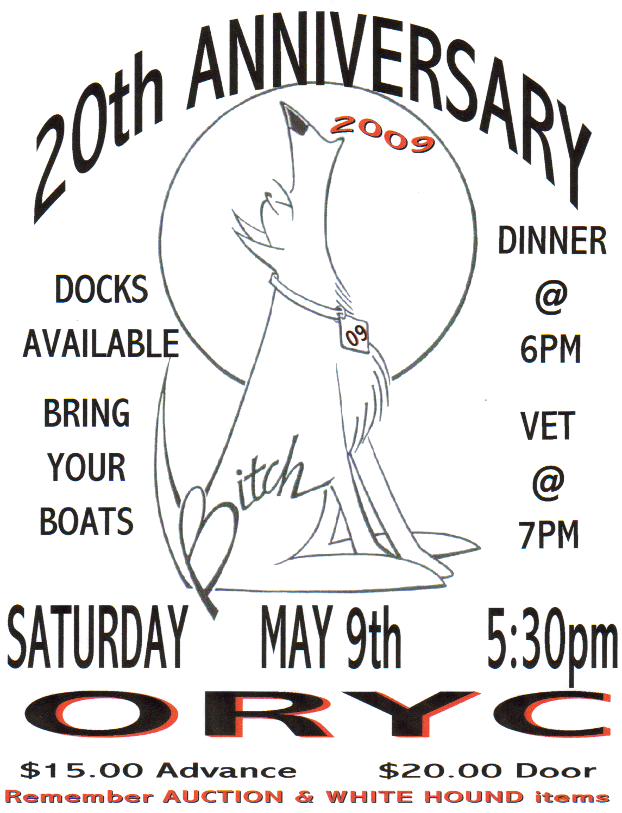

BITCH RULES

1. ONE BABY PER MEETING (MUST BE OF DRINKING AGE @ PERMIT ADDRESS)

2. RSVP AND ORDER FORM MUST BE IN BY DEADLINE. SEND MONEY FOR YOUR RSVP AND ORDER.

3. NO REFUND ...CONSIDER IT A DONATION TO ORKA, INC.

4. IF YOU DO NOT ATTEND ONE OF THE LAST 3 PARTIES, YOU WILL DROP FROM THE ADDRESS LISTING. HOWEVER IF YOU ARE UNABLE TO ATTEND AND YOU SEND YOUR $15 DONATION TO OUR CHARITY, YOU WILL BE MARKED AS ATTENDING AND WILL RECEIVE A NOTICE OF THE NEXT PARTY.

5. YOU ARE RESPONSIBLE FOR YOUR DRINKING AND ABILITY TO DRIVE, WE HAVE CAB ALERT AND WILL CALL THEM AT YOUR REQUEST.

6. WE ARE NOT WELCOME ACROSS THE STREET WHILE THE YELLOW DOGS ARE IN THE CLUB HOUSE BETWEEN THE HOURS OF 5:30 PM AND 10:30PM.
DO NOT TEST THE YELLOW DOGS OR ME ON THIS ONE

7. WHAT HAPPENS HERE DOES NOT LEAVE HERE VERBALLY OR IN PICTURES FORM.
YOU WILL BE REQUIRED TO SIGN A CONTRACT/RELEASE FORM @ THE DOOR.

8. THIS PARTY IS FOR YOU......WE WANT TO MAKE IT A PLACE TO LET YOUR HAIR DOWN AND FEEL COMFORTABLE DOING IT.
******************************CUT HERE & RETURN LOWER PORTION*****************************
COMPLETE THIS FORM IN FULL & RETURN BY 4-20-09
TOTAL
NUMBER OF PEOPLE ATTENDING @ 15$ EACH_______ _____________

BITCH CARD DO YOU NEED ONE? Y N BABY WILL GET ONE
FLAG 15$ EACH______ _____________
NUMBER
T-SHIRT REG (MAN CUT) $15 EACH ___/____/____/____ LONG/SHORT SLEEVE _____________
SIZE SIZE SIZE SIZE CIRCLE ONE
WOMEN CUT $20 EACH _____/____/____/____ SHORT SLEEVE _____________
SIZE SIZE SIZE SIZE
20 YR ANNIVERSARYT-SHIRT $15 EACH SIZE____ SIZE _____ SHORT SLEEVE _____________
BITCH LOGO (GOLD) PIN 20$ EACH_______ _____________
NUMBER
BOWL 2$ EACH_______ LEASH 2$ EACH_______ _____________
NUMBER NUMBER
MAKE CHECKS PAYABLE TO LINDA MOY TOTAL _____________
PLEASE ENCLOSE PAYMENT WITH RSVP SORRY NO REFUNDS----30$ CHARGE ON BAD CHECKS
Mail to: 6148 Edgewater Drive, Toledo, Ohio 43611
YOUR NAME_______ ______________________________YOUR PHONE NUMBER_____________________________

BABY NAME________________________________ADDRESS__________________________________________

CITY______________STATE________ZIP________PHONE___________________EMAIL____________________

*********************************************************************************************************
DATE RECV'D_____________ DATA BASE ENTRY____________ SHIRT ORDER____________
PIN ORDER___________ FLAG ORDER_________ BITCH CARD________



