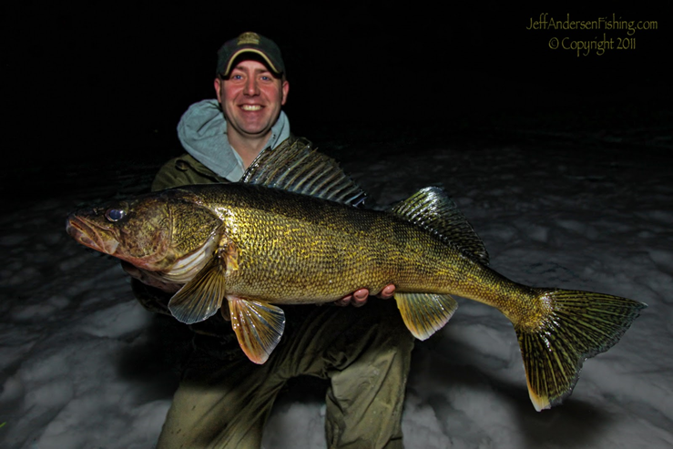  MAY 26, 2018  Swan boat club 2ND Annual walleye tournament  Start: 6:30 am Saturday May 26, 2018  Weigh In: 3:00 pm; Please be on time  Registration Fee: $25.00 per person  Cash Prizes: First, Second, Third Place; Biggest Walleye (wt.), skunked awards  Bag limit 5 per person  Registration, Continental Breakfast and Coffee in am (5:30am)  Overnight Dockage available (limited)  Swan Boat Club will be having a rib roast on Friday May 25, 2018, 5:30pm. Come on down for the festivities and registration the night before.  PRE-Registration: Call or text contacts:  Jim Beckner 734.752.5536  Corry Stanley 734.497.7589  Pete Halko 734.552.7558 | 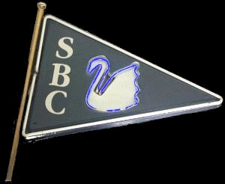  ────  Fish Fry to follow tournament $10.00  (Fish donated from tournament)  ────  Swans 2nd Annual  ────  Entertainment to follow fish fry  ────  Minutes off I-75 and I-275  Swan Boat Club  6332 Brancheau  Newport, MI  Club Phone: 734.586.2002

