SAVE THE DATE!
Saturday
October 24, 2015
WYC
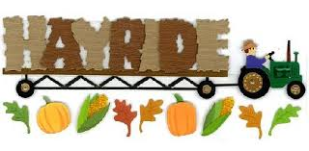
$15.00/Ticket

Wagon leaves WYC @ 4:30 p.m.
3 James DeSana Drive Wyandotte, MI 48192

Beverages and Food available for purchase at each stop!
Campfire and Pizza following Hayride!
For Reservations
Contact R/C Vivian Gebstadt
Call/text 313-682-4113
E-mail david48@comcast.net

